LAB Manual

| Name of Student : Parimal Kulkarni PRN 22070122138 |
| --- |
| **Semester : IV Year AY 23-24** |
| **Subject Title: Operating Systems Lab** |
| EXPERIMENT No : 2 Assignment No: 3 |
| TITLE : Basic Shell commands DoP :17-01-24 |

***Aim :*** Demonstrate the use of basic Shell commands

***Learning Outcome:*** *1. To understand the shell command*

*2. To Demonstrate the shell command*

***Hardware/Software* : *(It should be handwritten)***

***Theory: (It should be handwritten)***

***Output:*** snapshots of commands demonstration

Pwd,ls

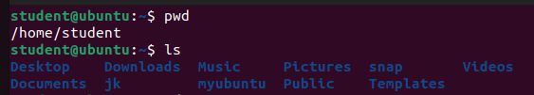

Cd,touch,cat,mkdir,rm,,bc

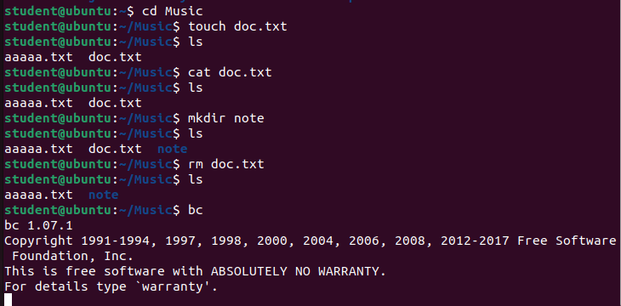

Tty,who

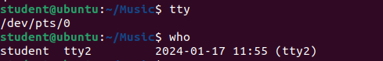

man

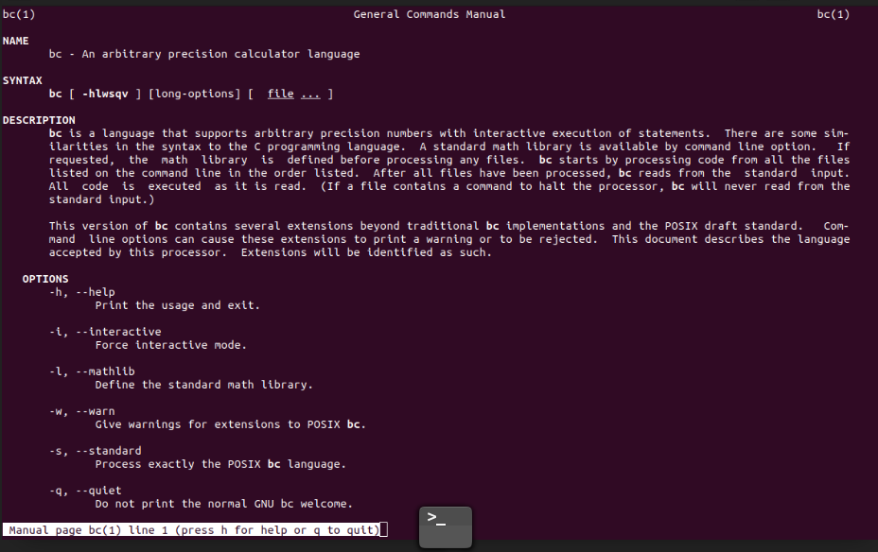

date

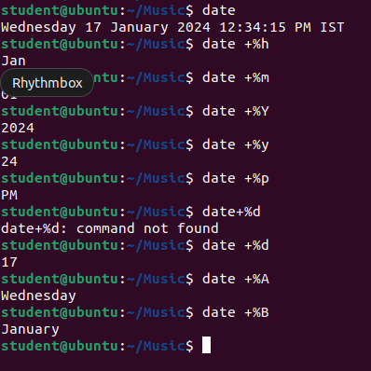

history

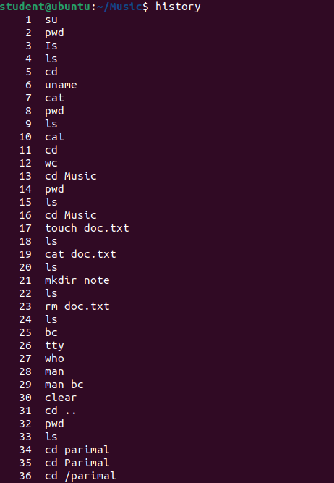

Ps,time

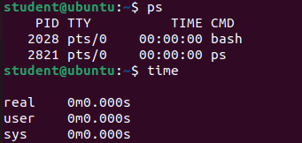

Head,tail,cp,cat,wc

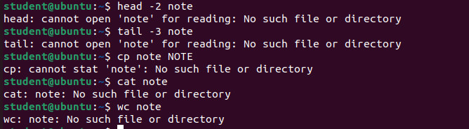

Su,sudo apt-get

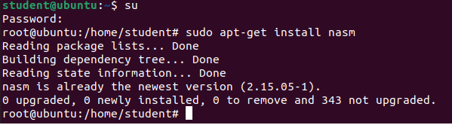

***Conclusion: (It should be handwritten)***

***i have learnt using linux terminal commands***

***assessment schemes.***

| Attendance | Discipline | Short oral | Correctness of Lab Report | Timely completion of Lab Report | Total marks  (10) | Signature of Teacher with Date |
| --- | --- | --- | --- | --- | --- | --- |
|  |  |  |  |  |  |  |